Task 7 – Evidence Report
Grafana Dashboards for the DSYS601 Observability Lab
Student | Kabir Singh Thukrai
Student ID | 99281336
Course | BCIS309 – Work Integrated Learning Project
Task | Task 7 – Grafana dashboard development (node/pod resource usage, restart/crash behaviour, overall workload health)
Dashboard | DSYS601 Workload Health (5 panels)
Repository | https://github.com/kat0870/dsys601-k8s-observability-lab
Date | 28 September 2026

1. What this task was about
The brief asks for Grafana dashboards that cover three things: node and pod resource usage, pod restart or crash behaviour, and overall workload health. Prometheus was already collecting the data after Task 6, so this task was really about turning that data into something a person can read at a glance.
I also wanted the dashboard to survive a cluster rebuild. Anything built by clicking around in Grafana lives only in Grafana's own database, and the brief expects the environment to be rebuilt between cohorts. So the second half of this task is about getting the dashboard into the repo and making it load by itself.

2. Getting into Grafana
Grafana was installed in Task 6 as part of the same Helm chart as Prometheus, so there was nothing new to deploy. I reached it with a port-forward and logged in as admin using the lab password from values.yaml.
kubectl port-forward -n monitoring svc/kube-prometheus-stack-grafana 3000:80
# then open http://localhost:3000 in Firefox on the VM

3. What the Helm chart already gave me
The chart comes with a lot of ready-made Kubernetes dashboards. Searching for "kubernetes" in Grafana lists them, including Compute Resources for the cluster, namespaces, nodes and individual pods (Figure 1).
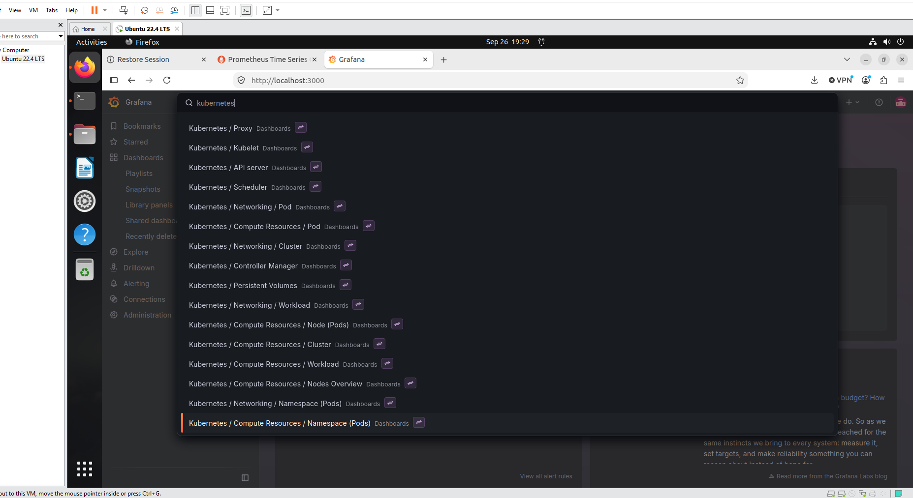
Figure 1. Built-in Kubernetes dashboards that came with the chart
I opened Compute Resources / Cluster first. It shows CPU and memory use broken down by namespace, plus a quota table per namespace, and it was showing real numbers from the cluster (Figure 2). That already covers a good part of the resource usage and workload health requirements.
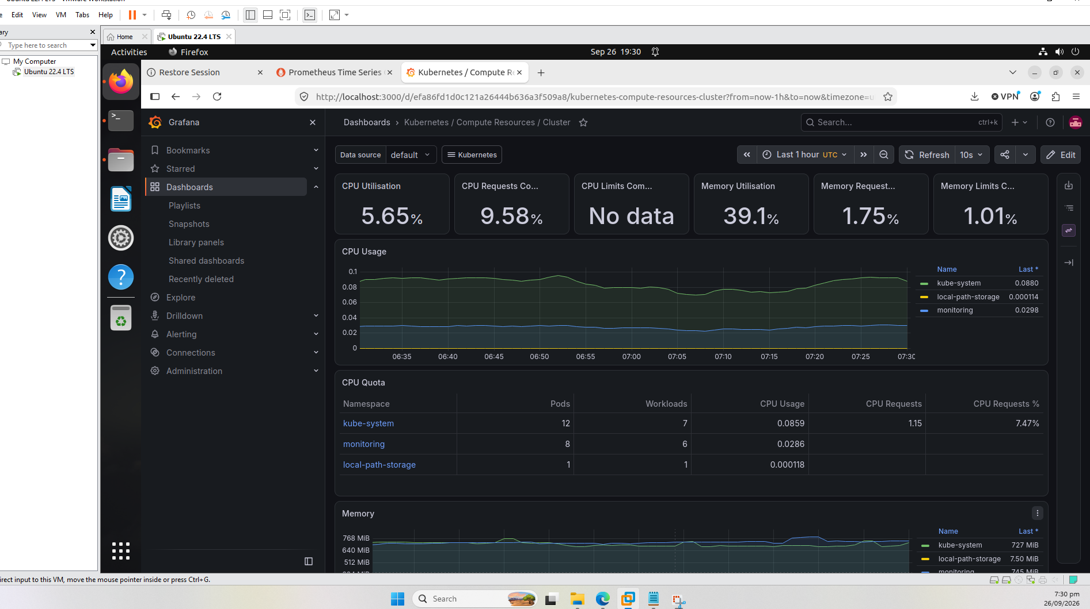
Figure 2. Compute Resources / Cluster dashboard showing live data
A hiccup: the Pod dashboard said "No data"
When I opened Compute Resources / Pod it showed "No data" everywhere. The namespace filter was on "default", and when I went to pick demo-app it wasn't in the list at all.
Running kubectl get pods -n demo-app explained why: there was nothing there. I had deleted and rebuilt the Kind cluster a few times while re-testing for Task 2, and every new cluster starts empty, so the demo application from Task 5 was gone. I re-applied the manifest from the repo and all five pods were running again within a minute (Figure 3).
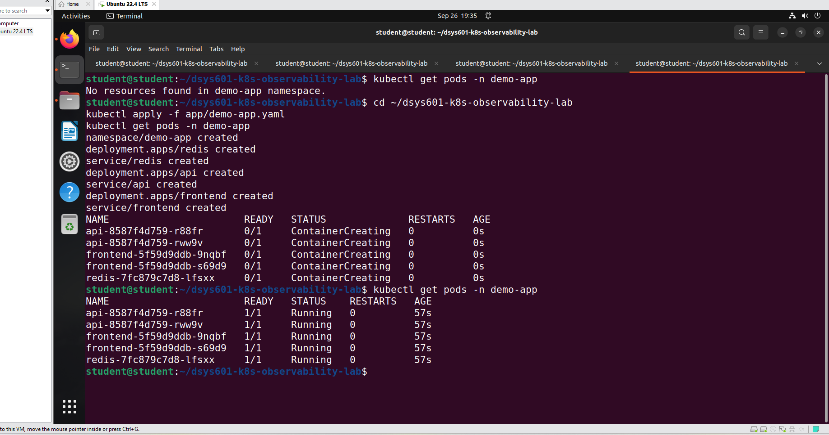
Figure 3. demo-app namespace empty, then redeployed from app/demo-app.yaml
After that demo-app showed up in the namespace dropdown, and the Pod dashboard filled in with CPU usage, throttling and quota for the api pod (Figure 4).
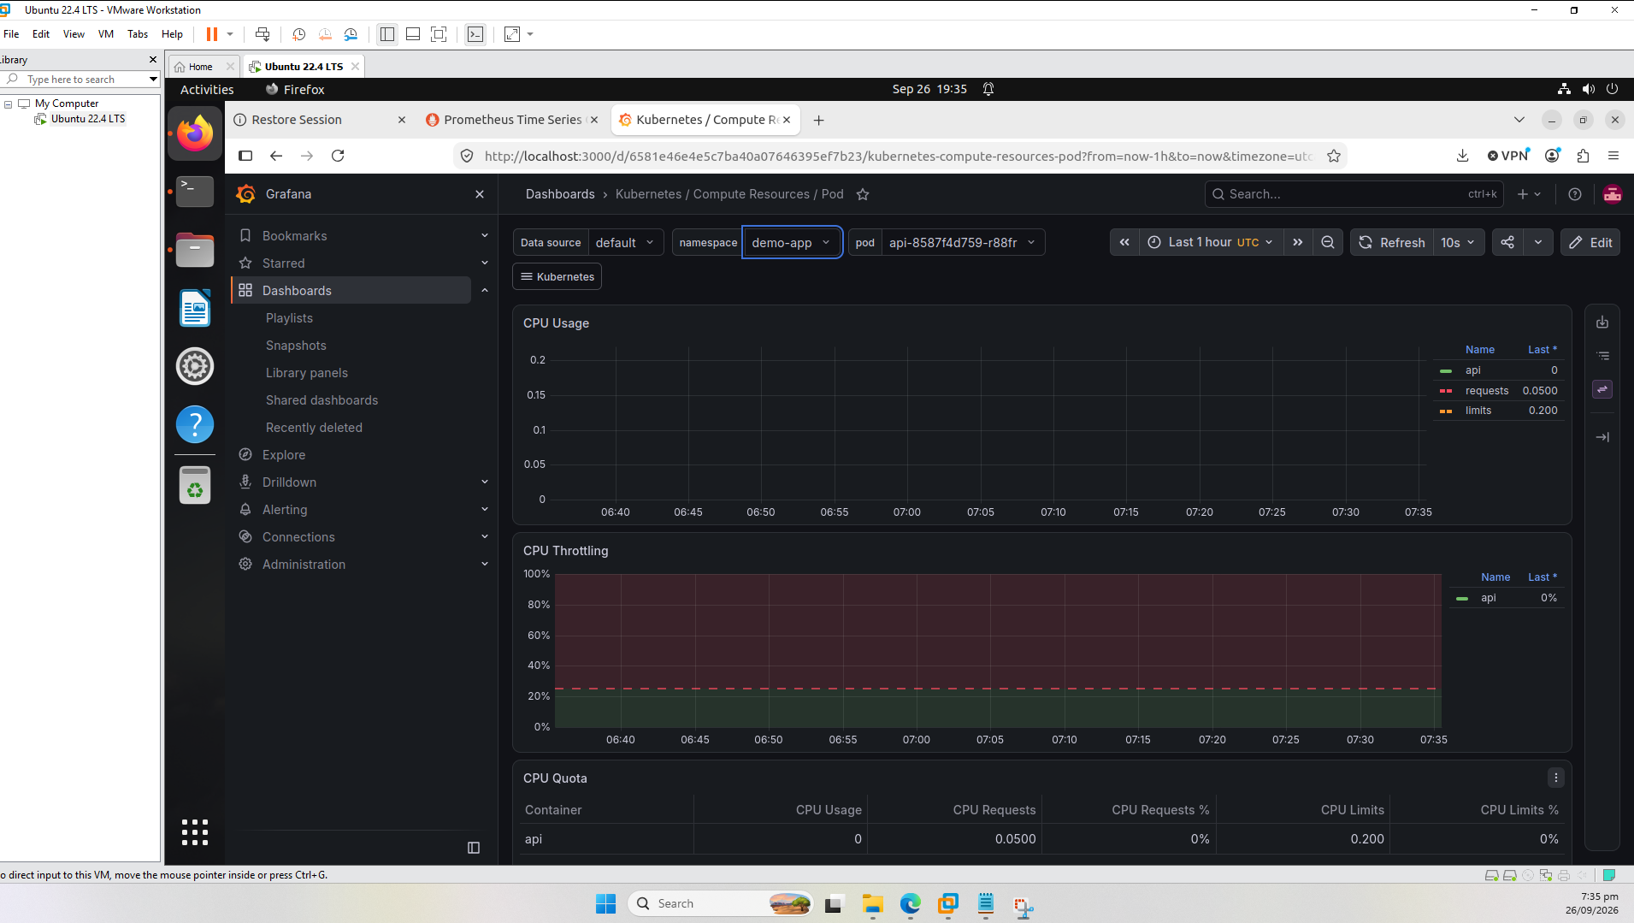
Figure 4. Compute Resources / Pod dashboard with demo-app selected
This is worth remembering for the handover notes: after any cluster rebuild the demo app has to be applied again, otherwise the dashboards look broken when they are not.
What the built-in dashboards did not cover
The two I opened, Cluster and Pod, are about CPU and memory. Neither shows restart counts, and restart or crash behaviour is one of the three things the brief asks for. Rather than hunt through every built-in dashboard, I built a small one of my own that puts the important things for the demo app on a single screen.

4. Building the dashboard
I created a new dashboard called DSYS601 Workload Health with five panels. All of them use the Prometheus data source. The first four are limited to the demo-app namespace so the graphs show the application itself rather than the whole cluster.
Panel | What it shows | Why it is there
Container Restarts by Pod | Restart count for each demo-app container | Restart and crash behaviour
Pods Not Ready | 1 for any pod that is not ready, otherwise 0 | Overall workload health
Memory Usage by Pod | Working-set memory per pod | Pod resource usage
CPU Usage by Pod | CPU used per pod, averaged over 5 minutes | Pod resource usage
Node Memory Utilisation (%) | Memory used on each node | Node resource usage

Panel 1: Container Restarts by Pod
sum by (namespace, pod) (kube_pod_container_status_restarts_total{namespace="demo-app"})
This counts how many times each container has been restarted, using the metric from kube-state-metrics. Grafana showed a yellow hint suggesting I wrap it in rate(), because it is a counter. I left it as the raw count on purpose, since what I want to see is the actual number of restarts.
All five lines sit at zero right now because nothing has crashed (Figure 5). That is the correct healthy result. When I break a pod on purpose in Task 9, this is the panel that should step upwards.
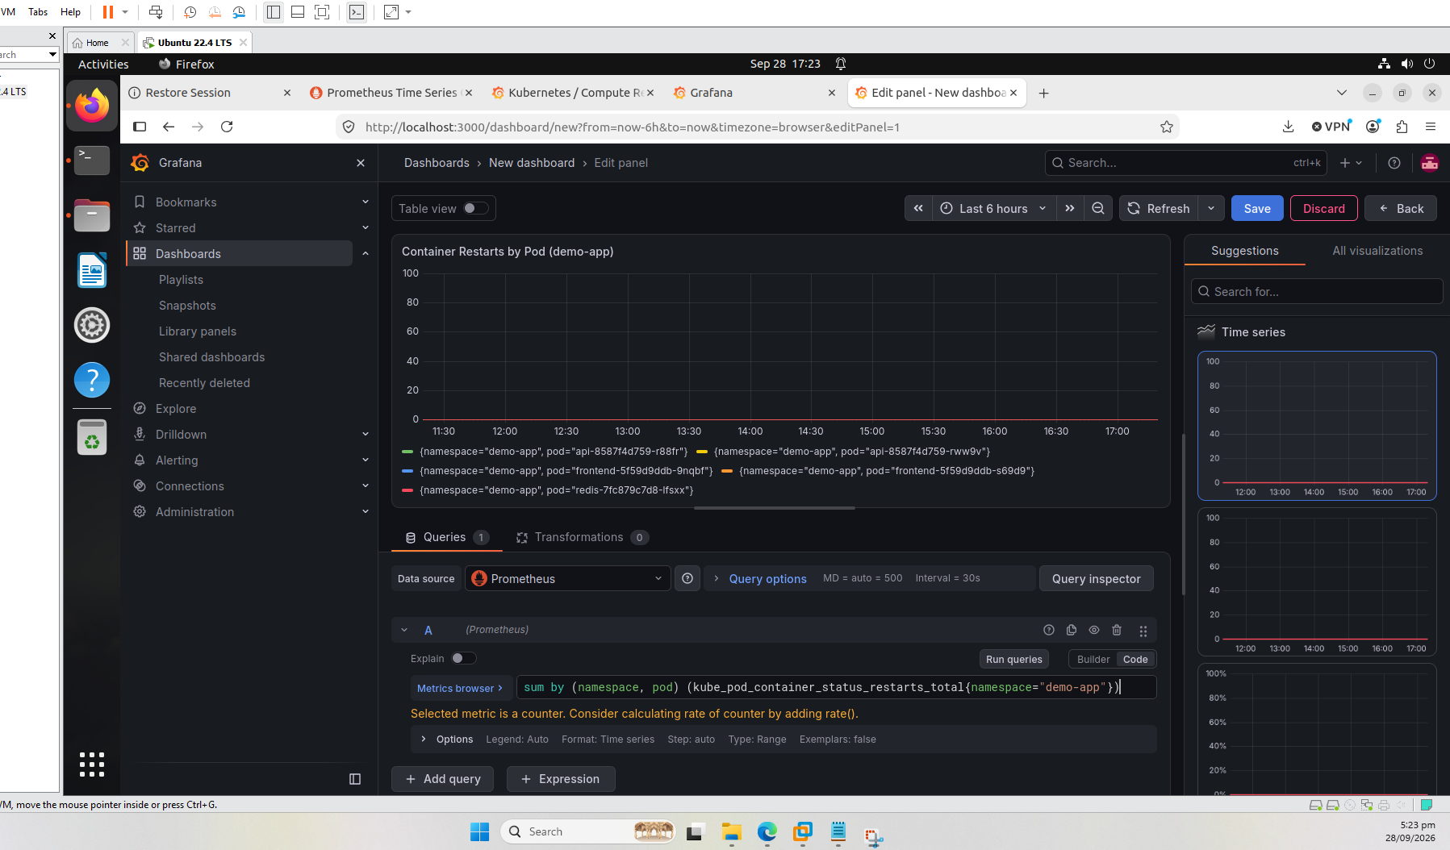
Figure 5. Restart panel: one flat line at 0 for each demo-app pod
Panel 2: Pods Not Ready
sum by (pod) (kube_pod_status_ready{namespace="demo-app", condition="false"})
A pod can be running but not ready to take traffic, which is different from crashing. This panel counts pods whose ready condition is false. Again everything is at zero (Figure 6), meaning all five pods are ready.
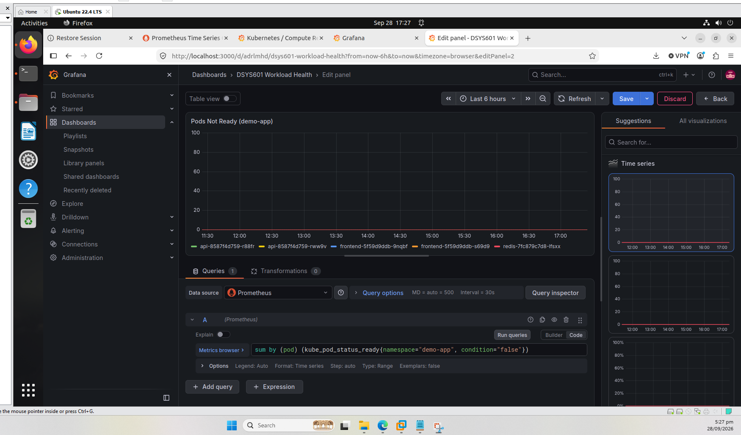
Figure 6. Pods Not Ready panel: all five demo-app pods at 0
Panel 3: Memory Usage by Pod
sum by (pod) (container_memory_working_set_bytes{namespace="demo-app", container!="", container!="POD"})
Working-set memory is the figure Kubernetes itself looks at when it decides whether a container is near its limit, so it is the right one to track for the memory alert coming in Task 8. The two container filters remove the empty entries and the pause container so each line is a real container.
I set the unit to bytes (IEC) so the axis reads in MiB instead of raw numbers like 4500000. Each demo-app pod is using roughly 2 to 4 MiB (Figure 7).
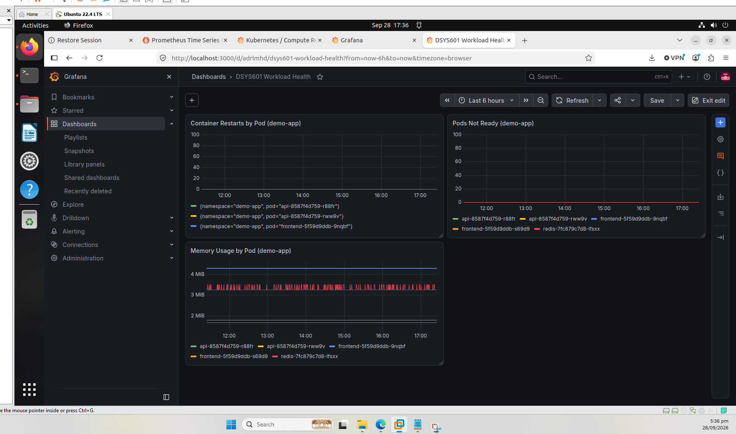
Figure 7. Dashboard with the memory panel added, axis in MiB
Panel 4: CPU Usage by Pod
sum by (pod) (rate(container_cpu_usage_seconds_total{namespace="demo-app", container!="", container!="POD"}[5m]))
This is CPU time used per second, averaged over five minutes, so a value of 1 would mean one full core. The lines sit around 0.006 (Figure 8), which is tiny, but that is expected because the demo app is idle. It will be more interesting once there is some load.
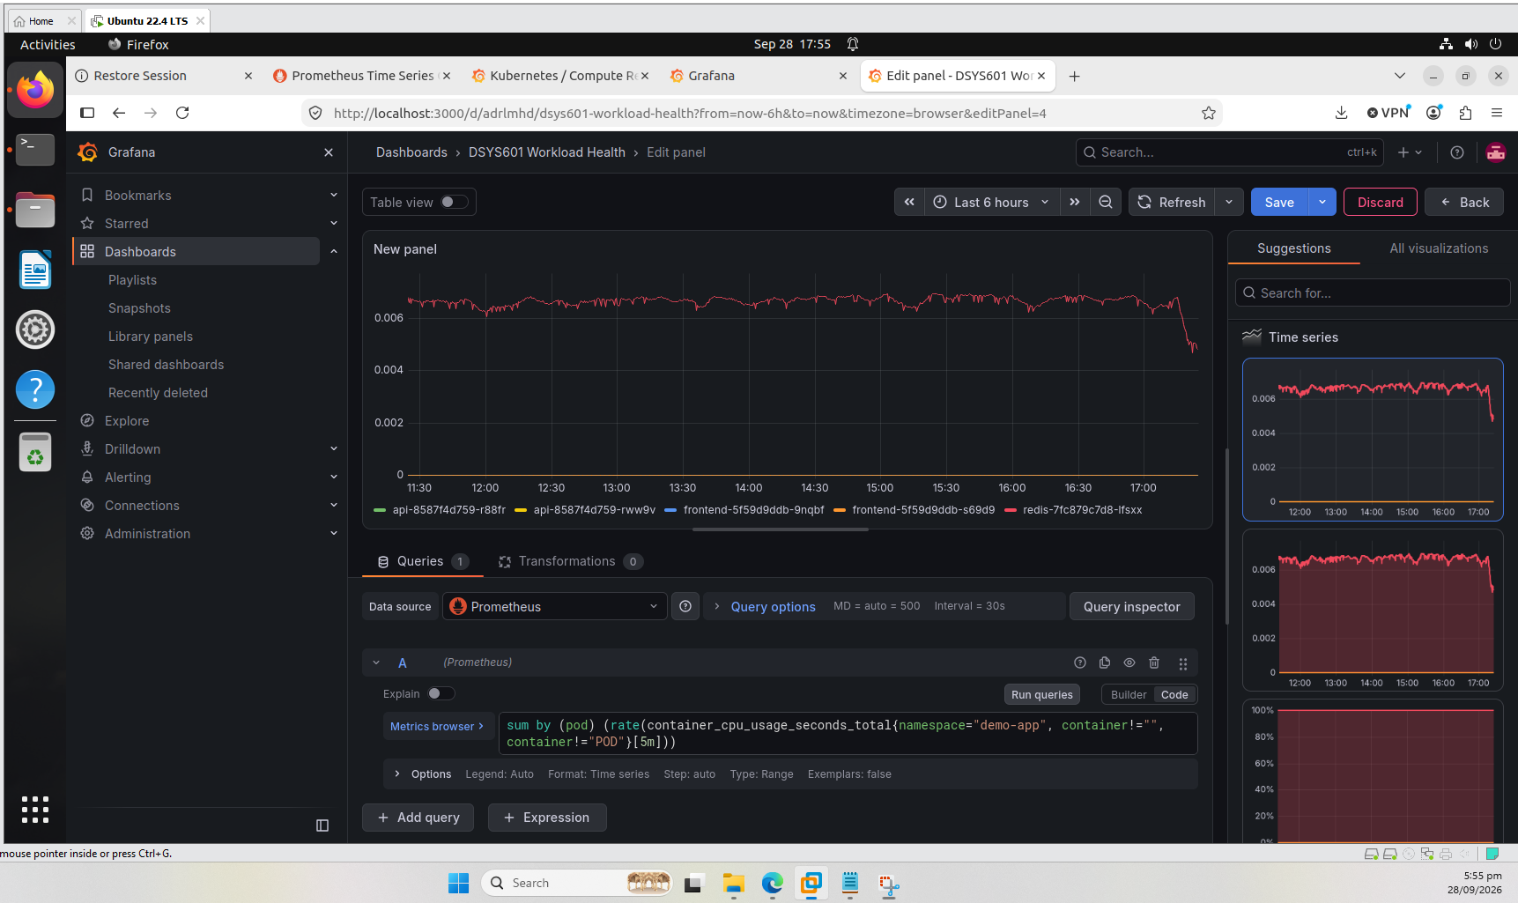
Figure 8. CPU panel showing the idle demo app using well under 1% of a core
Panel 5: Node Memory Utilisation (%)
100 * (1 - node_memory_MemAvailable_bytes / node_memory_MemTotal_bytes)
This one uses node-exporter rather than kube-state-metrics, so it is the panel that shows the node side of resource usage. It shows three lines, one per node, sitting between roughly 45% and 49% (Figure 9). I set the unit to percent (0-100).
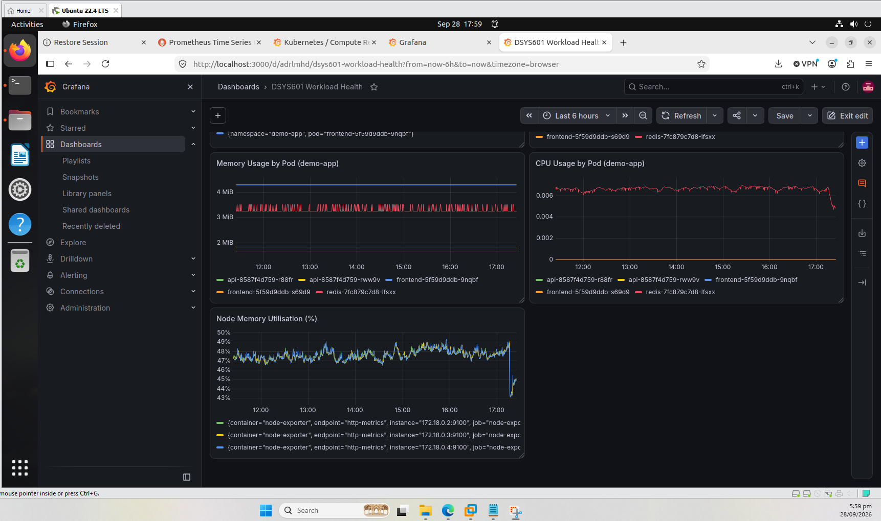
Figure 9. Node memory panel, along with the CPU and memory panels above it

5. Saving the dashboard in the repo
To keep the dashboard outside Grafana's database I exported it as JSON through Grafana's API and saved it under monitoring/dashboards in the repo. The jq step sets the internal database id to null, so the file can be loaded into a fresh Grafana without clashing.
curl -s -u admin:<password> http://localhost:3000/api/dashboards/uid/adrlmhd \
| jq '.dashboard | .id=null' > monitoring/dashboards/dsys601-workload-health.json
The file is 532 lines long and contains the titles of all five panels plus the dashboard title, which I checked with wc and grep before committing (Figure 10).
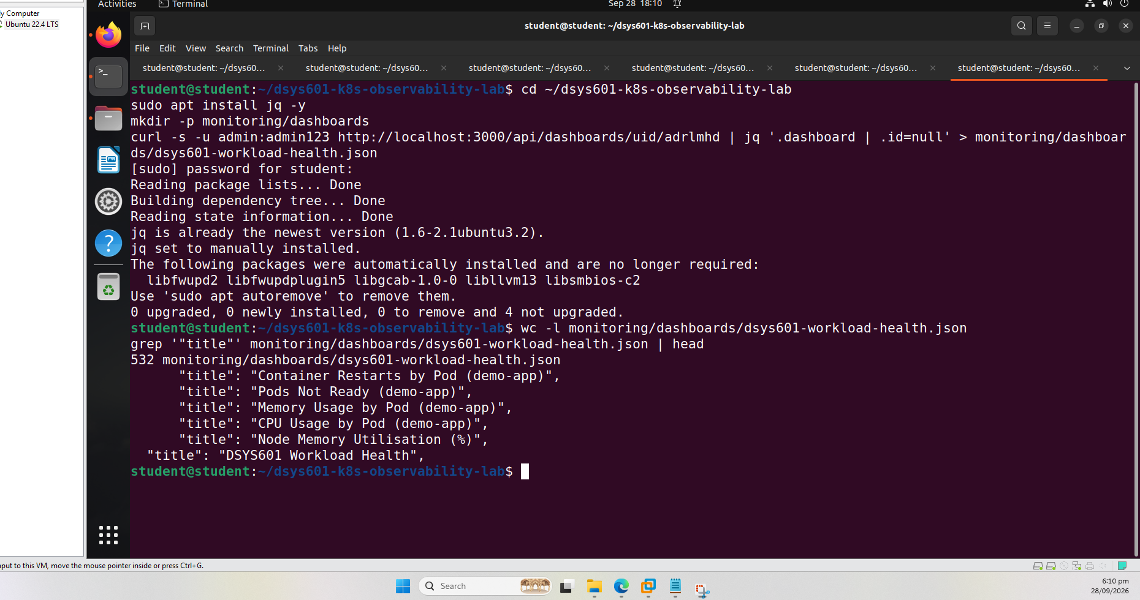
Figure 10. Exported JSON: 532 lines, five panel titles plus the dashboard title
I then committed and pushed it (commit c690ff2, Figure 11).
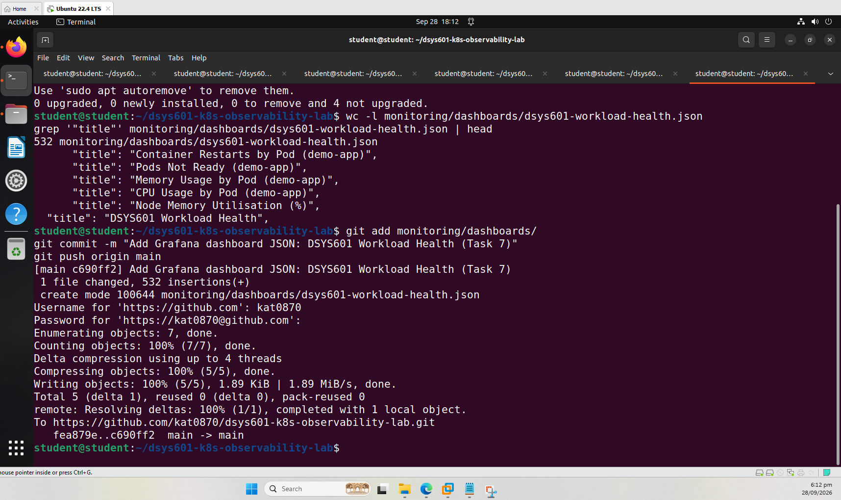
Figure 11. Dashboard JSON committed and pushed to GitHub

6. Making the dashboard load by itself
Having the JSON in the repo is only half of it. If someone has to import it by hand after every rebuild, it is not really reproducible.
The Grafana pod in this chart runs a sidecar container that watches for ConfigMaps carrying the label grafana_dashboard=1 and loads any dashboard JSON inside them. So I added a step to monitoring/setup-monitoring.sh that wraps the JSON file in a ConfigMap and applies the label (Figure 12).
kubectl create configmap dsys601-workload-health \
--namespace monitoring \
--from-file="$SCRIPT_DIR/dashboards/dsys601-workload-health.json" \
--dry-run=client -o yaml | kubectl apply -f -
kubectl label configmap dsys601-workload-health \
--namespace monitoring grafana_dashboard=1 --overwrite
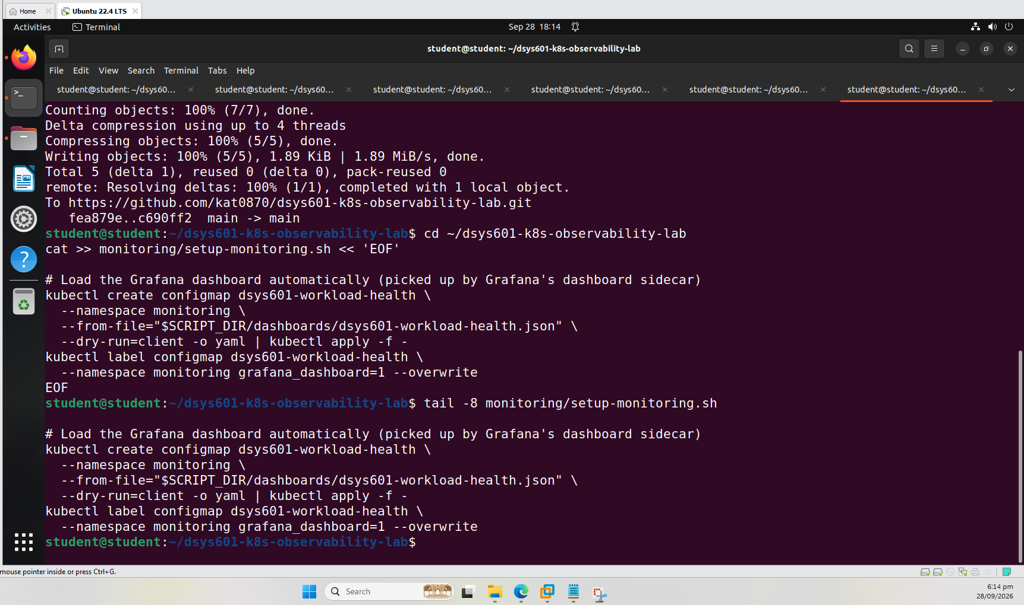
Figure 12. The new lines at the end of setup-monitoring.sh
Testing that it really works
I did not want to assume this worked, so I tested it properly. I deleted the dashboard from Grafana through the API, then created the ConfigMap from the JSON file. The API confirmed the delete, and the ConfigMap was created and labelled (Figure 13).
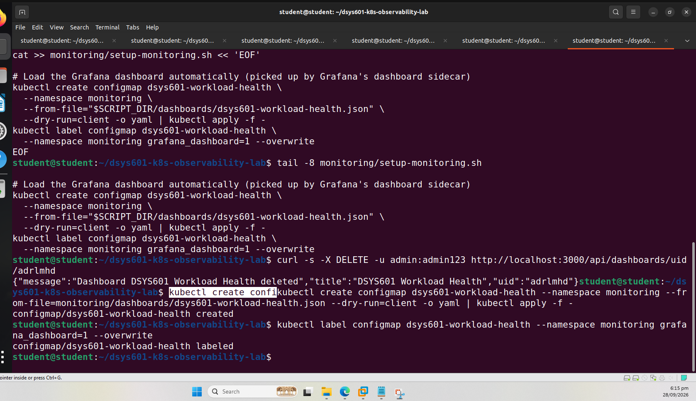
Figure 13. Dashboard deleted through the API, then the ConfigMap created and labelled
About a minute later the dashboard was back, with the same address and all five panels showing live data (Figure 14). That shows a rebuilt cluster will get the dashboard back from the repo without anyone touching Grafana.
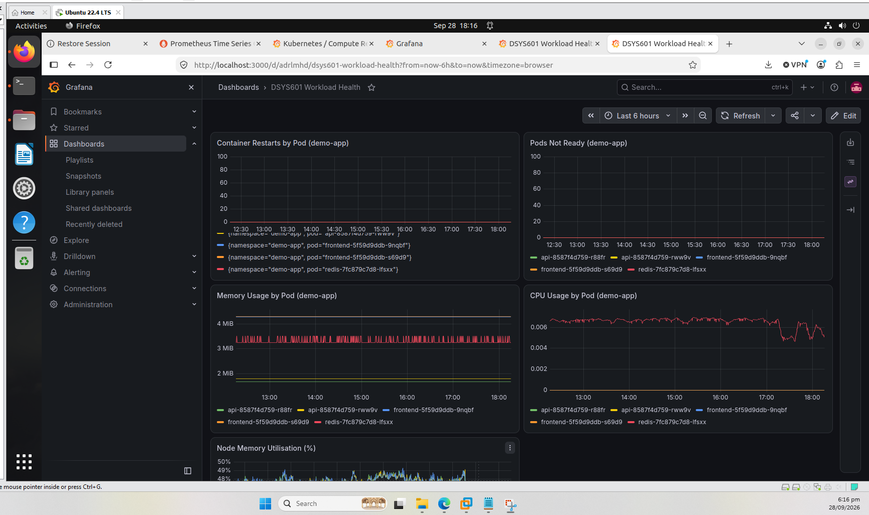
Figure 14. Dashboard restored from the ConfigMap after being deleted
The final commit for this step was 69d8167 (Figure 15). The first push attempt in that screenshot was rejected with an invalid-token message; the second attempt went through.
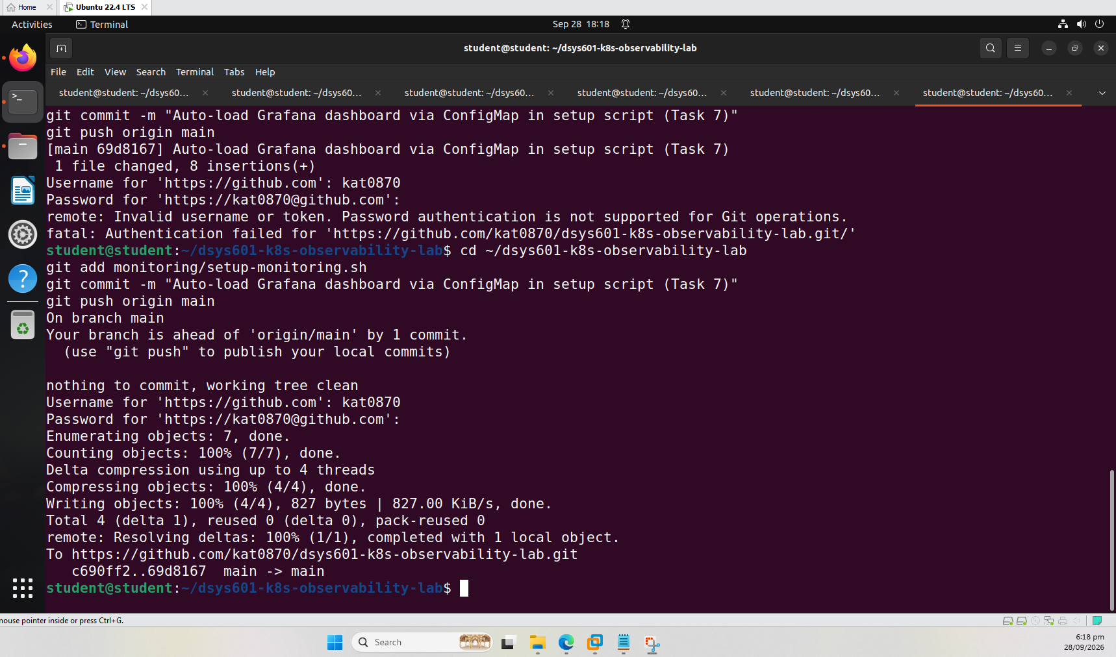
Figure 15. Updated setup script pushed to GitHub
One consequence to keep in mind: the dashboard now comes from the file, so any future changes should be made in the JSON (or re-exported) and the ConfigMap applied again. A change saved only inside Grafana would be lost on the next rebuild.

7. Something I noticed about the node panel
The three lines on the Node Memory panel sit almost exactly on top of each other. That is not a mistake in the query. The three Kubernetes nodes are Docker containers running on the same VM, and node-exporter inside each one is reading the same underlying host memory, so they all report nearly the same figure.
In practice this means the panel tells me how the VM is doing rather than how each node is doing on its own. It is a limit of running a multi-node cluster on one host, not something wrong with the dashboard. It also makes pod and container level metrics, like the memory and restart panels above, the safer basis for the alerts in Task 8, because those are genuinely separate per workload.

8. Where this leaves Task 7
Brief requirement | Covered by
Node and pod resource usage | Memory, CPU and Node Memory panels, plus the built-in Cluster and Pod dashboards
Pod restart / crash behaviour | Container Restarts by Pod panel
Overall workload health | Pods Not Ready panel, plus the built-in Cluster dashboard
Reproducible from GitHub | Dashboard JSON in monitoring/dashboards, loaded automatically by setup-monitoring.sh

To be upfront about the limits: the restart and readiness panels are flat at zero because nothing is failing yet, so at this point they only show the healthy baseline. They will only prove themselves in Task 9, when I break a workload on purpose and check that they react.
Next is Task 8, writing the Alertmanager rules for the failure conditions in the brief (CrashLoopBackOff, a container near its memory limit, a pod stuck not-ready, and resource pressure).
Repository: https://github.com/kat0870/dsys601-k8s-observability-lab

